Michael Jackson vs. Prince – Let’s Compare the Legends
Prince and Michael Jackson are popular culture icons, who defined music genres and influenced entertainers forever. What we gained from these artists are funky, R&B influenced, dance inspiring jams that resonate with most people who’ve ever given them a listen. With great popularity and worldwide acclaim comes a unique life with all the benefits and downsides of such notoriety. While there are many similarities between these musical icons, Prince and Michael Jackson have obvious differences. In this article we will take a look at what makes them similar, different, as well as what artists today are influenced by their styles.

The King of Pop
Michael Jackson has been described as the King of Pop, and he explored a variety of music genres, including pop, soul, rhythm and blues, funk, rock, disco, post-disco, dance-pop and new jack swing in his career which started from childhood. He was a persistent hit maker for over four decades, with such chart topping albums as Off the Wall (1979), Thriller (1982), Bad (1987), Dangerous (1991), HIStory (1995) and Invincible (2001). He has sold over 750 million albums, worldwide. Thriller has persisted as the best selling album of all time, with over 65 million sales worldwide. His top hits include “Thriller,” “Billy Jean,” and “Don’t Stop Till You Get Enough.”

The Purple One
Prince was a musical innovator and known for his eclectic work, flamboyant stage presence, extravagant dress and makeup, and wide vocal range. His music integrates a wide variety of styles, including funk, rock, R&B, new wave, soul, psychedelia, and pop. He has sold over 100 million records worldwide, making him one of the best-selling artists of all time. His top hits include “When Doves Cry,” “Kiss,” and “Let’s Go Crazy.” He wrote the soundtrack and starred in the 1984 film Purple Rain, which won the Academy Award for Best Musical.

What’s Similar?
Both men took elements of funk, R&B, and disco and put that into their music. They have both said they were influenced by James Brown, Little Richard, and Jackie Wilson, among others. They both created a unique sound that defined the music of the times.
Both are of African American descent, and both became reclusive and retreated to private residences later in life where they recorded and spent most of their time: Neverland in California for Jackson, and Paisley Park in Minnesota for Prince. Both had controversial actions that made headlines – Jackson and his legal troubles, Prince and his religious fervor, as well as using a symbol for his professional name to upset his label. Both wanted to distance themselves from their labels. Jackson has famously called Sony head Tommy Mottola a racist.
Sadly, another similarity is that they both died all too young – Jackson at 50 and Prince at 57 – and in unfortunate ways. Questionable medical advice, treatments, and powerful medications being used improperly were definitely a part of Jackson’s death, and now looks like similar issues may have played a part in Prince’s death.
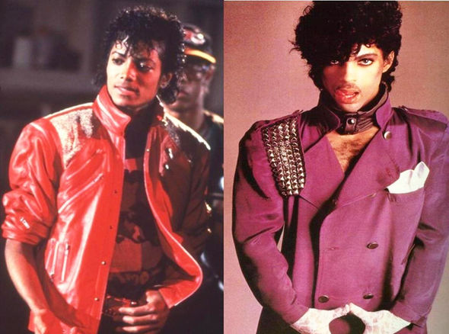

How Do They Differ?
Some of the major differences are that Prince was a multi-instrumentalist – playing guitar, drums, percussion, bass, keyboard and synthesizer. Michael did not play any instruments live, only during the recording process, and preferred to use his voice to beatbox the other instruments for the songs he composed. Prince’s musical influences could be viewed as more rock influenced including Jimmy Hendrix, Mick Jagger, and guitarists like Carlos Santana. However Jackson was also influenced by rock music so that’s not a huge difference. Michael will forever be remembered for his innovative and unique dancing style, which became as much a part of his presence as his music, whereas Prince’s skillful guitar playing (he is considered one of the best guitar players of all time) became part of his stage presence.

